

web-based game

CS 230 Project Software Design Template
Version 1.0

Table of Contents

CS 230 Project Software Design Template 1
Table of Contents 2
Document Revision History 2
Executive Summary 3
Requirements 3
Design Constraints 3
System Architecture View 3
Domain Model 3
Evaluation 5
Recommendations 8

Document Revision History

Version | Date | Author | Comments
4.0 | 06/20/206 | Mohamed Fahim El-Hewie | ● Recommendations

Instructions
Fill in all bracketed information on page one (the cover page), in the Document Revision History table, and below each header. Under each header, remove the bracketed prompt and write your own paragraph response covering the indicated information.

Executive Summary

This project intends to transform an existing Android game into multiplatform web-based application. It tackles the problems of accessing various devices, platforms, and software logics in order to manage memory conflicts across distributed network environment. The main emphasis of the project is to validate and enforce uniqueness of names and identifiers of all games, teams, and players. That ensures strict and seamlessly tracking of single instance by multiple players across the web. The application is limited to drawings from a library of stock drawings and cannot apply to live streaming. This limitation is attributed to the unpredictably complex streams of various platforms with various memory management systems.

Requirements
- A game will have the ability to have one or more teams involved.
- Each team will have multiple players assigned to it.
- Game and team names must be unique to allow users to check whether a name is in use when choosing a team name.
- Only one instance of the game can exist in memory at any given time. This can be accomplished by creating unique identifiers for each instance of a game, team, or player

Design Constraints
The proposed design is constrained by the multiplicity of platforms across the web and the multiplicity of participants accessing a uniquely running game. Platforms multiplicity poses critical demands on memory and storage of large library of images. Participants’ multiplicity is managed by implementing Singleton class in conjunction with a superclass holder of common unique identifiers. The critical constraint of expedient streaming and receiving images is largely dependent on distributed loads of data streaming across networks

System Architecture View

Please note: There is nothing required here for these projects, but this section serves as a reminder that describing the system and subsystem architecture present in the application, including physical components or tiers, may be required for other projects. A logical topology of the communication and storage aspects is also necessary to understand the overall architecture and should be provided.

Domain Model (Lavieri. 2019)

<Describe the UML class diagram provided below. Explain how the classes relate to each other. Identify any object-oriented programming principles that are demonstrated in the diagram and how they are used to fulfill the software requirements efficiently.>

Class Relationships:

- Inheritance of attributes and methods of superclass Entity by subclasses: Player, Team, and Game, rendered code reusable. Reducing redundant code blocks in subclasses enhanced readability to great extent.
- Aggregation of Players in Teams, Teams in Games, facilitates tracking names and identifiers through limited processes of iterations.
- Dependency of class GameSerive on the three simple classes: Player, Game, and Team, allowed the localization of accessors in a single implementation class. That facilitates debugging and refining the code by organized modules of related purposes.
- Realization is demonstrated by class SingletonTester that invokes implementation class to validate its Singleton’s behavior.
- Association between Driver class and GameService class enable the execution of java project by proving entry point, where input and output demonstrate the proper execution of the interconnected classes.

Object Oriented Principles:

Encapsulation: The three simple classes Player, Team, and Game are clear examples on how bundling variables in separate classes, and in separate blocks within each class, enabled shielding, organizing, and securing data in localized, confined, and recognizable locations within the software project. Every module in the project encapsulates meaningfully related components that render the code easy to understand and debug.

Inheritance: Class Entity lumps the common attributes and methods of accessing name and identifier into a single superclass. Extending Entity to subclasses resulted in removing many blocks on redundant code that are already residing in the superclass.

Polymorphism: Superclass Entity hosts two basic attributes; name and identifier. However, the two attributes are overridden onto multiple domains of players, games, and teams, without altering the accessor methods. Thus, every child class is able to implement the parent’s attributes and methods according to its own requirement.

Abstraction: All classes implemented in this java projects show the essential methods and attributes of implementing computation, while complex operations run in the background, need not distract the user by their arcane and confounding details.

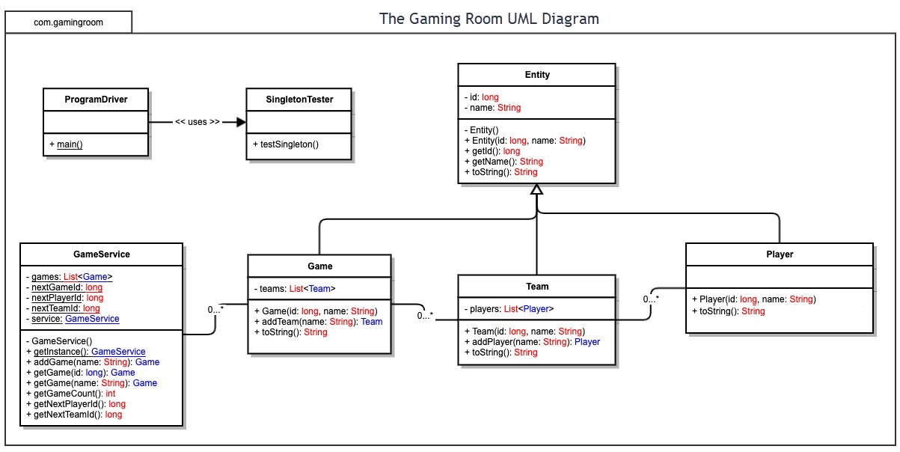

Evaluation (SILBERSCHATZ, 2008)

Using your experience to evaluate the characteristics, advantages, and weaknesses of each operating platform (Linux, Mac, and Windows) as well as mobile devices, consider the requirements outlined below and articulate your findings for each. As you complete the table, keep in mind your client’s requirements and look at the situation holistically, as it all has to work together.

In each cell, remove the bracketed prompt and write your own paragraph response covering the indicated information.

Development Requirements | Mac | Linux | Windows | Mobile Devices
Server Side | Rarely recommended due to high hardware cost and lack of support of propriety macOS.  Easier to manage GUI over command line instructions. | Highly recommended open-source, cost-effective, with high stability achieved by large pool of developers. Require specialized technical expertise. | High familiarly of integrated environment that comes with higher cost of licensing and propriety resources. | Impractical as server s with restricted hardware characteristics designed for portability. Battery-life time prohibits mobile devices from performing as network servers.
Server Side | - Developers favorite for selective users.  - Highest GUI.  - Highest security and stability.  - Propriety, expensive hardware.  - Limited scalability and options.  - Server app requires third party software. | - Industry standard.  - Free licensing.  - High stability and customization.  - Require command-line experience.  - Most cost-effective.  - Hosting requires propriety hardware such as as Mac Studio and Mini. | - Enterprise standard integrated propriety technology.  - GUI shortens learning curve.  - VS, .NET, IIS  - Costly licensing.  - Requires high resources.  - Vulnerable to threats.  - License based on number of processor cores.  - Access License depend on number of users and devices. | - Require installing app on client frontend.  - Portable, integrated camera/GPS/  touch.  - Battery and screen size limitation.  - Fragmented access to network.  - No native enterprise hosting.
Server Side | - Web browser access on all platforms, cross platform compatibility.  - No installations needed, computation done on web-based hosting.  - Independent from front-end devices.  - Servers process and scale operations optimized by managing resources for thousands of players.  - Dynamic load handling adapt to extremes of variability of users’ demands.  - RESTful API parses, synchronizes, and delivers thousands of inputs, consistently and dynamically.
Client Side | Heavy hardware investment in propriety Apple products is weighed against highly stable Unix environment. Requires specialized expertise in macOS. | Affordable open-source but requires longer development and testing periods to ensure compatibility across different bases of platforms. | Supporting multiple types of clients is faster to develop and release due to targeting large base of windows users. Higher cost for native development due to limited market size. | Complex hardware features require high proficiency in languages like Objective-C and Java, requires cycles of reviews for Android and macOS.
Client Side | - Web-based is cross-platform compatible leading to reduced cost.  - Single application with cross-platform compatibility is cheaper than separate native apps.  - Accelerated release time of 3 to 6 months for single codebase application.  - Require expertise in modern web development standards:  - HTML5, CSS3, JavaScript.  - Responsive design automatically adjust to mobile screens, tablets, and monitors.  - Code must comply with cross-browser testing: Chrome, Firefox, Edge.  - RESTful API decoupling of clients from servers.  - Extensive testing of cross-platform compatibility to remove bugs.
Development Tools | Languages:  Swift,  Objectice-C,  C++, and  JavaScript  IDE:  VS Code  Xcode  AppCode | Languages:  C/ C++  Python  Java  Rust  Go  IDE:  VS Code  Eclipse | Languages:  C#/ C++  Python  Java  Rust  JavaScript  IDE:  MS Visual Studio  VS Code  Eclipse | Languages:  Swift,  Objectice-C,  C++, and  JavaScript  IDE:  VS Code  Android Studio  MS Visual Studio
Development Tools |  | Apple App Store Requires registration membership fee $99/year |  | Google Play Store’s membership is one-time $25.
Development Tools | - Free IDE’s: Visual Studio, Android Studio, Xcode, and Eclipse.  - Paid subscriptions IDE’s: WebStorm or IntelliJ.  - Platform publishing fees.  - Collaborative team integration of specific devices hardware:  - Camera control, Bluetooth.  - Extensive QA testing to ensure seamless continuous hardware integration.  - One Codebase cross-platform requires cross-functional team of developers.

Recommendations

1. Operating Platform Architectures to The Gaming Room:

Among the two Linux Ubuntu servers, AWS (Amazon Web Services) and GCP (Google Compute Engine), I recommend the Ubuntu Server on Google. [8] The reasons are as follows:

- It provides the scalability, cost-efficiency, and cross-platform compatibility needed to expand Draw It or Lose It beyond mobile into a seamless, web-based multiplayer environment.
- It offers vastly superior core-and-RAM customization and simpler, more predictable baseline pay-as-you-go billing. The highly customizable instances can independently adjust the number of vCPU cores and the precise gigabytes of RAM of Ubuntu server needs, eliminating wasted resource expenses.
- It uses the linux-gcp kernel, a multi-user system, providing protection between processes and running multiple processes according to a time-sharing scheduler. Newly created processes can share selective parts of their execution environment with their parent processes, allowing multithreaded programming. Multiple networking protocols can be accessed simultaneously through the socket interface. [9]
- It utilizes Google's Compute Engine Virtual Ethernet (gVNIC) for optimized, accelerated networking. Networking is globally distributed by default, Ubuntu VM can attach to a single global Virtual Private Cloud (VPC) that spans multiple geographic regions without setting up complex cross-region peering networks.
- It features native integration with scale-out-optimized hardware like Google Tau VMs. It links natively into the Google Cloud Administrator console.

2. Operating Systems Architectures

Linux uses a modular, layered architecture that strictly separates hardware and user applications. Because the source code is free and open, developers can modify the kernel, compile the changes, and reboot to load new functionality. System libraries allow game room applications to request system services easily without manually coding low-level instructions. Meanwhile, the User Space confines instances and background processes to run safely, ensuring that any crash or instability remains contained and does not destabilize the core operating system. [4], [9]

3. Storage Management

For multi-platform gaming, a cloud object storage system is utilized, combined with a NoSQL database. Google Cloud Storage saves game assets and drawing files efficiently. A NoSQL database is used to quickly track unique team names, game sessions, and player metrics. High availability is accomplished by implementing storage tiering (categorizes data by access frequency and value, then automatically moves it between different storage media), data redundancy, and automated backups.

4. Memory Management

- Physical RAM & Swap: Linux naturally balances active data in RAM and moves idle anonymous memory to swap space based on the system's swappiness configuration.
- Page Sharing & Copy-On-Write (COW): When a game server forks, the child processes initially share the exact same physical memory pages as the parent. Linux only allocates new physical memory when a process attempts to modify a page, making it highly efficient for multiple identical instances.
- Demand Paging: Linux uses a lazy allocation strategy. It does not load data into physical RAM until the processor attempts to read or write to that specific memory page, triggering a page fault.
- Memory Isolation: The translation between virtual memory addresses and physical RAM addresses is strictly managed by the kernel and the CPU's Memory Management Unit (MMU). This prevents one game instance from accessing or corrupting the memory space of another.

5. Distributed Systems and Networks

To enable cross-platform play (Android, Web, iOS), a robust distributed network architecture is implemented. This utilizes RESTful APIs for standard data retrieval and WebSockets to establish real-time, bi-directional communication between client devices and the server. A stateless microservices architecture is adopted to ensure high availability and horizontal scaling. To handle localized network outages or dropped connections, built-in session-recovery logic works alongside centralized state-management services to reconnect clients with minimal data loss.

6. Security

Protecting user data across multiple platforms requires a multi-layered defense. [4] In-Transit and At-Rest Encryption utilizes Transport Layer Security (TLS/SSL) to encrypt communication packets and encrypt databases at rest. Authentication implements OAuth 2.0 or token-based authentication to verify user identities and ensure only authorized players can join private game sessions. Linux provides built-in firewall protections (like iptables or ufw) UncomplicatedFirewall - Ubuntu Wiki and restricted Linux file permissions, allowing limited access to sensitive data on a strict need-to-know basis.

References:

[1] Silberschatz, Abraham. et. al., 2009. "Operating System Concepts," 8th Edition.
Chapter 3, Processes.
[2] Silberschatz, Abraham. et. al., 2009. "Operating System Concepts," 8th Edition.
Section 12.4 Disk Scheduling.
[3] Silberschatz, Abraham. et. al., 2009. "Operating System Concepts," 8th Edition.
10.1.5 Internal File Structure.
[4] Silberschatz, Abraham. et. al., 2009. "Operating System Concepts," 8th Edition.
21.2 Design Principles.
[5] Stallings, William. 2019. “Computer Organization and Architecture
Designing for Performance” Eleventh Edition. “The Principle of Locality.”
[6] Richard Durso. 2022. "Over-Provisioning SSD for Increased Performance and Write Endurance."
https://medium.com/@reefland/over-provisioning-ssd-for-increased-performance-and-write-endurance-142feb015b4e
[7] Jhaveri, Sankhesh, et. al. 2026. “WebGPU – One Graphics API To Rule Them All”
https://www.kitware.com/webgpu-one-graphics-api-to-rule-them-all/
[8] Mavrogiannopoulos, Nikos. 2021. “Cloud-optimized Linux kernels – what makes Ubuntu the top OS across the clouds”
https://ubuntu.com/blog/cloud-optimized-linux-kernels

[9] Wikibooks. 2026. “Multitasking functionality.”
https://en.wikibooks.org/wiki/The_Linux_Kernel/Multitasking

=================== END ==================

